Psoriasis arthritis prevalence in the clinical practice of dermatologist in North-West Tuscany centres of excellence for psoriasis: a screening experience

**Introduction**

Psoriasis is a common dermatologic disease with high prevalence (around the 2 %) in western countries (1); psoriasis arthritis is a chronic inflammatory disease that will develop during cutaneous psoriasis in percentage that vary from 6 % to 48 % depending on the cohorts examined (1, 2).

Typical manifestations of psoriasis arthritis are the distal articulations involvement, spondilitis and dattilitis in 50 % of patients and beyond, and ungual psoriasis up to 80 % of cases (1-3).

The early manifestations of the artropathy is usually sneaky and often seen by patients and physicians as not specific muscular-scheletric pain, also because of the partial knowledge of the relations between cutaneous psoriasis and psoriasic arthritis.

The consequence of this partial knowledge is a delayed diagnosis and an underestimation of the disease severity; actually psoriasic arthritis has an aggressive course in around the 30 % of the cases and lead to an early articular damage, that could be largely reduced or blocked with an early treatment, in particular with anti-TNFalfa agents (4).

If the impact on disability of early diagnosis and treatment, the high prevalence of psoriasis in the general population and the significant percentage of psoriasic arthritis that will be seen within 10 years from dermatologic psoriasis beginning are to be considered (2), it should be clear that the early screening for psoriasic arthritis from the dermatologists is highly desiderable.

Various clinical tools as questionnaires were developed with the aim of performing an effective screening and of sending patients to the rheumatologist as soon as possible, even if the real effectivenes of these tools is still under investigation (5-8).

Speaking of the Italian context, in the region Tuscany a lot of interventions on a local level have been implemented to boost dermatologists and rheumatologists interactions, with the aim to improve patients assistence and provide the most individualized care possible to each patient clinical presentation.

MATERIALS AND METHOD:

In this general frame of reference, the experience of 5 dermatologic centres of excellence (Livorno, Pisa, Massa, Lucca, Viareggio), within the Tuscany region has been reported in this paper. In these centres all consecutive patients with psoriasis accessing the outpatients facilities between December 2014 and February 2015 were screened for the presence of a previous diagnosis of arthritis and for symptoms in the articular system. The screening was performed by means of some questions chosen and shared by dermatologists in charge in the centres aforementioned on the basis of their clinical experience.

|  |
| --- |
| *Have you ever had pain radiating from the lombar region to the tight, but not going beyond the knee?* |
| *Have you experienced frequent pain or articular stiffness when you wake up that improve along the day with movement?* |
| *Have you ever had a finger fully swollen, like a sausage?* |
| *Have you ever had swelling and pain in the heels, knees or hands?* |
| *Have you ever had pain in the calcaneus?* |
| *Have you ever been diagnosed with arthritis?* |

If at least one of these symptoms were present the dermatologist could advice the patient to undergo a rheumatological consultation.

In addition the dermatologist asked for localization and clinical features of psoriasis.

|  |
| --- |
| Scalp psoriasis |
| Palmoplantar psoriasis |
| Nail psoriasis |
| Intertrigo and perianal psoriasis |
| Extended psoriasis |
| Plaque psoriasis |
| Pustular psoriasis |
| Guttate psoriasis |
| Erythrodermic psoriasis |

**Results**

In the five operating units of dermatology evaluated, 134 patients affected with psoriasis had been observed, 32 (24 %) of which answered “yes” at the question “*Have you ever been diagnosed with arthritis*?”.

The sex distribution 55F, 76M (global sample F/M ratio 72 %) shows a higher percentage in the arthritis group (table 1).

**Table 1. Sample patients divided according to sex and arthrits diagnosis.**

|  |  |  |
| --- | --- | --- |
|  | Psoriasis without arthritis | Psoriasis with arthritis |
| F | 40 | 15 |
| M | 59 | 17 |
| F/M ratio | 68 % | 88 % |

The mean age of the 134 patients has been 57.17 years, with a standard deviation of 15.12. The division by groups with and without arthritis has resulted in significant higher mean age in the arthritis group (figure 1). In particular the arthritis group had a mean age of 62.5 years (sd= 13.7) while in the group without arthritis diagnosis the mean age had been of 55.4 years (sd= 15.2).

**Figure 1. Age in groups without and with arthritis.**

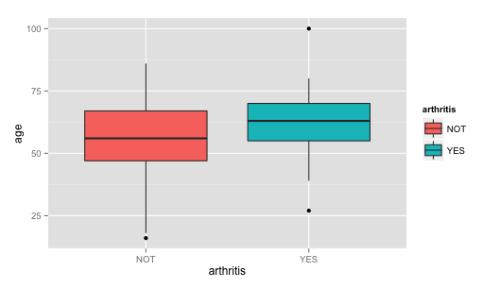

The clinical pictures of psoriasis was not different between patients with and without arthritis: 31 of 32 arthritis patients and 97 of 102 patients without arthritis diagnosis have been diagnosed with plaque psoriasis (97 % vs 95 %). Ungueal psoriasis was slightly more common in the arthritis group (11 of 29 observations, 38 %) compared to the group without arthritis diagnosis (26 of 101 observations, 26 %) (figure 2).

**Figure 2. Division according to the presence of arthritis (horizontal YES or NOT)**

**and of ungueal psoriasis (vertical YES or NO)**

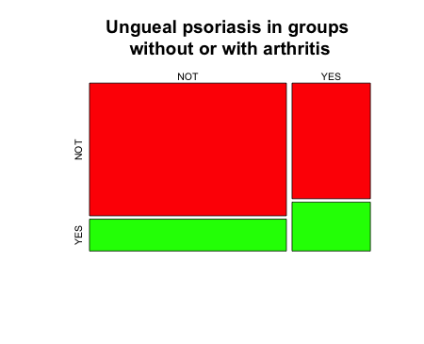

Patients with psoriasis on more than 50 % of the body surface were 40 of 101 in the group without arthritis (40 % ca.) and 7 of 29 (24 % ca.) in the arthritis group (figure 3).

**Figure 3. Division according to arthritis diagnosis (horizontal YES or NOT) and psoriasis on more than 50 % of body surface (vertical YES or NOT)**

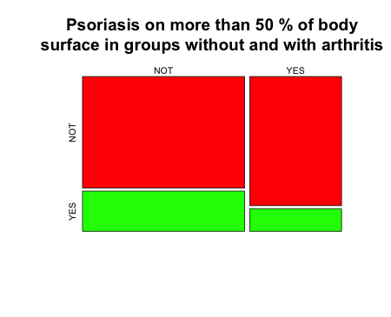

Current therapies are summarized in the table 2, divided by groups without and with arthritis diagnosis. The percentage of patients with psoriasis and arthritis diagnosis treated with biological drugs was 57 % (17 patients of 30) while in the group of patients without arthritis diagnosis the percentage was 24.5 % (24 patients of 98).

**Table 2. Drugs employed divided by groups without or with arthritis diagnosis**

|  |  |  |
| --- | --- | --- |
| **Therapies** | **Psoriasis without arthritis diagnosis** (data available on 98 patients) | **Psoriasis with arthritis diagnosis** (data available on 30 patients) |
| Acitretine | 3 | 2 |
| Cyclosporine | 4 | 0 |
| Etanercept | 9 | 10 |
| Phototherapy | 47 | 8 |
| Adalimumab | 11 | 7 |
| Methotrexate | 4 | 3 |
| Infliximab | 1 | 0 |
| Ustekinumab | 3 | 0 |
| Topic drugs | 16 | 0 |
| Biological drugs total | 24 (24.5 % of the total) | 17 (57 % of the total) |

Time between psoriasis diagnosis and arthritis diagnosis (data available on 23 patients) was quite spread out, between -9 years (arthritis diagnosis made before psoriasis diagnosis) and + 33 years (psoriasis diagnosis 33 years before arthritis diagnosis) (table 3 and figure 4).

**Table 3. Time (years) between diagnosis of psoriasis and diagnosis of arthritis**

|  |  |  |  |  |  |
| --- | --- | --- | --- | --- | --- |
| **Minimum** | **Quartile 25** | **Median** | **Mean** | **Quartile 75** | **Maximum** |
| -9 | 1 | 3 | 7 | 13 | 33 |

**Figure 4. Boxplot of time between diagnosis of psoriasis and diagnosis of arthritis (years)**



The counts of rheumatological symptoms (lumbocrural pain, pain/stiffness at awakening, fingers swelling, pain/swelling hands-feets-joints, calcaneus pain) were in a higher percentage in patients with a diagnosis of arthritis as expected.

In table 4 anamnestic rheumatological symptoms in the two groups were summarized.

**Table 4. Counts and percentage () of anamnestic rheumatological symptoms in the groups with or without arthritis diagnosis**

|  |  |  |  |  |  |  |
| --- | --- | --- | --- | --- | --- | --- |
|  | **Lumbocrural pain** | **pain/stiffness at awakening** | **Joints pain or swelling** | **fingers swelling** | **Calcaneus pain** | **Missing data** |
| **Patients with arthritis (n. 32)** | 25 (78) | 28 (87) | 22 (69) | 14 (44) | 17 (53) | 2(6) |
| **Patients without arthritis (n. 102)** | 23 (22.5) | 27 (26.5) | 30 (29.4) | 12 (11.8) | 18 (17.6) | 11 (10.7) |

**Discussion and conclusions**

The North-West Tuscany centres of excellence for psoriasis screening experience has provided interesting data, both to indicate the screening questions effectiveness and to evaluate the relation between cutaneous psoriasis and psoriasic arthropathy. In a fully consistent way with published data, suggesting a significant comorbidity of these two conditions, on 134 patients observed in 5 operating units, a diagnosis of arthritis had been made in 32 (24 %) cases, as recorded through the questionnaire administered.

The analysis of time elapsed between the diagnosis of cutaneous psoriasis and that of arthritis has shown a median of 3 years and a mean of 7 years. Consistently with the data on diagnosis, the mean age of patients with cutaneous psoriasis/arthritis comorbidity was 7 years higher.

With regard to the psoriasis symptoms, the higher presence of ungueal psoriasis in the arthritis group (38 % versus 26 %) and the higher presence of psoriasis on more than 50 % of body surface in the group without arthritis (40 % rispetto al 24 %) are of interest.

No surprise come from the analysis of rheumatological symptoms; all pain, swelling and stiffness of joints were present in a much higher percentage in patients with arthritis diagnosis, as expected.

Of particular interest is the data on therapies, with biological drugs in 57 % of patients with arthritis and only in 24.5 % in patients with cutaneous psoriasis symptoms only, even with impressive ones (cutaneous psoriasis in more than 50 % of the body surface in 40 % of patients without arthritis).

Conclusions that could be drawn from this dermatologic inpatients in the Tuscany region of Italy could be summarized in the confirmation of the opportunity of screening programs on arthropaty in cutaneous psoriasis patients. The questionnaire employed has detected about a quarter of psoriasis inpatients with relevant arthropatic features, complex patients for whom more challenging therapies, like biological drugs, are often recommended and that were administered in the sample in more than half of the cases.

**Bibliography**

1. Fitzgerald O. In: Kelley's Textbook of Rheumatology, 8th Ed. 2009;10:1201–16.
2. Gladman DD. Psoriatic arthritis from Wright's era until today. J Rheumatol 2009;36 Suppl 83:4–8
3. Reich K. Approach to managing patients with nail psoriasis. JEADV 2009;23 Suppl 1:15–21.
4. [Olivieri I](http://www.ncbi.nlm.nih.gov/pubmed/?term=Olivieri%20I%5BAuthor%5D&cauthor=true&cauthor_uid=18176985), [D'Angelo S](http://www.ncbi.nlm.nih.gov/pubmed/?term=D'Angelo%20S%5BAuthor%5D&cauthor=true&cauthor_uid=18176985), [Padula A](http://www.ncbi.nlm.nih.gov/pubmed/?term=Padula%20A%5BAuthor%5D&cauthor=true&cauthor_uid=18176985), [Palazzi C](http://www.ncbi.nlm.nih.gov/pubmed/?term=Palazzi%20C%5BAuthor%5D&cauthor=true&cauthor_uid=18176985). The challenge of early diagnosis of psoriatic arthritis.. J Rheumatol 2008;35:3–5.
5. Husni ME, Meyer KH, Cohen DS, Mody E, Qureshi AA. The PASE questionnaire: pilot-testing a Psoriatic Arthritis Screening and Evualtion tool. J Am Acad Dermatol 2007;57:581-7.
6. Gladman D, Schentag CT, Tom BDM, et al Development and initial validation of a screening questionnaire for psoriatic arthritis: the Toronto Psoriatic Arthritis Screen (ToPAS). Ann Rheum Dis 2009;68:497-501.
7. Ibrahim GH, Buch MH, Lawson C, Waxman R, Helliwell PS. Evaluation of an existing screening tool for psoriatic arthritis in people with psoriasis and the development of a new instrument: the Psoriatic Epidemiology Screening Tool (PEST) questionnaire. Clin Exp Rheumatol 2009;27:469-74.
8. Tinazzi I, Adami S, Zanolin EM, Caimmi C, Confente S, Girolomoni G, Gisondi P, Biasi D, McGonagle D. The early psoriatic arthritis screening questionnaire: a simple and fast method for the identification of arthritis in patients with poriasis. Rheumatology (Oxford) 2012;51):2058-63.